**Full Stack Development with MERN Project Documentation**

**Introduction:**

Complaint Management System (CMS) is designed to streamline the process of registering, tracking, and resolving complaints efficiently. This system will allow users to log their grievances online, ensuring faster responses and resolution times. It offers an easy-to-use interface for both users and administrators to monitor complaint statuses. Additionally, the CMS ensures transparency by keeping records of all interactions and providing updates at each step of the resolution process. This project aims to enhance customer service and operational efficiency across various sectors.

**Project Title:** Complaint Management System (CMS)

**Team Members:**

Team Leader: Arun P

Team Members: Rajnish Choudhary R, Dhanush Kumar S, Subash K.

**Project Overview:**

**Purpose:**

The Complaint Management System (CMS) is designed to streamline the process of lodging, tracking, and resolving complaints within an organization. It provides a user-friendly platform for users to register complaints and for administrators to manage and resolve them effectively.

**Goals:**

* Provide a digital interface to lodge complaints.
* Track the status of complaints.
* Allow admins to monitor and resolve complaints in a timely manner.

**Features:**

**User Authentication:** Register, login, and secure access to the system.

**Dashboard:** A user-specific dashboard for managing complaints.

**Complaint System:** Submission, tracking, and management of complaints.

**Admin Panel:** View all complaints, resolve or close complaints.

**Responsive Design:** The system is accessible across devices.

**Scenario:**

Scenario: John, a customer, recently encountered a problem with a product he purchased online. He notices a defect in the item and decides to file a complaint using the Online Complaint Registration and Management System.

1. **User Registration and Login:**
   * John visits the complaint management system's website and clicks on the "Sign Up" button to create a new account.
   * He fills out the registration form, providing his full name, email address, and a secure password.
   * After submitting the form, John receives a verification email and confirms his account.
   * He then logs into the system using his email and password.
2. **Complaint Submission:**
   * Upon logging in, John is redirected to the dashboard where he sees options to register a new complaint.
   * He clicks on the "Submit Complaint" button and fills out the complaint form.
   * John describes the issue in detail, attaches relevant documents or images showcasing the defect, and provides additional information such as his contact details and the product's purchase date.
   * After reviewing the information, John submits the complaint.
3. **Tracking and Notifications:**
   * After submitting the complaint, John receives a confirmation message indicating that his complaint has been successfully registered.
   * He navigates to the "My Complaints" section of the dashboard, where he can track the status of his complaint in real-time.
   * John receives email notifications whenever there is an update on his complaint, such as it being assigned to an agent or its resolution status.
4. **Interaction with Agent:**
   * A customer service agent, Sarah, is assigned to handle John's complaint.
   * Sarah reviews the details provided by John and contacts him through the system's built-in messaging feature.
   * John receives a notification about Sarah's message and accesses the chat window to communicate with her.
   * They discuss the issue further, and Sarah assures John that the company will investigate and resolve the problem promptly.
5. **Resolution and Feedback:**
   * After investigating the complaint, the company identifies the defect in the product and offers John a replacement or refund.
   * John receives a notification informing him of the resolution, along with instructions on how to proceed.
   * He provides feedback on his experience with the complaint handling process, expressing his satisfaction with the prompt resolution and courteous service provided by Sarah.
6. **Admin Management:**
   * Meanwhile, the system administrator monitors all complaints registered on the platform.
   * The admin assigns complaints to agents based on their workload and expertise.
   * They oversee the overall operation of the complaint management system, ensuring compliance with platform policies and regulations

**Technical Architecture:**

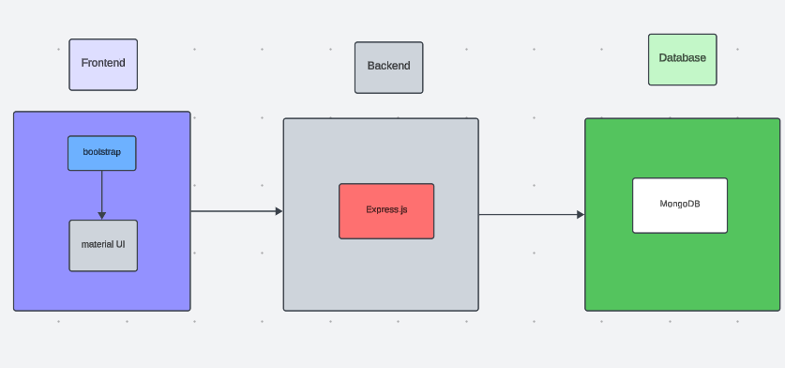

* The technical architecture of our online complaint registration and management app follows a client-server model, where the frontend serves as the client and the backend acts as the server. The frontend encompasses not only the user interface and presentation but also incorporates the axios library to connect with backend easily by using RESTful Apis.
* The frontend utilizes the bootstrap and material UI library to establish real-time and better UI experience for any user whether it is agent, admin or ordinary user working on it.
* On the backend side, we employ Express.js frameworks to handle the server-side logic and communication.
* For data storage and retrieval, our backend relies on MongoDB. MongoDB allows for efficient and scalable storage of user data, including user profiles, for complaints registration, etc. It ensures reliable and quick access to the necessary information during registration of user or any complaints.
* Together, the frontend and backend components, along with socket.io, Express.js, WebRTC API, and MongoDB, form a comprehensive technical architecture for our video conference app. This architecture enables real-time communication, efficient data exchange, and seamless integration, ensuring a smooth and immersive video conferencing experience for all users.

**Folder Structure**

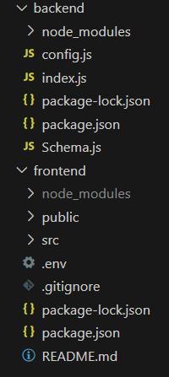

**Client Folder (Frontend) Structure:**

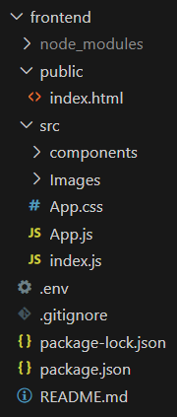

`/src`: Contains the source code for the React app.

components/: Houses all the reusable components like `Navbar`, `Login`, `Register`, `Dashboard`.

pages/: Contains specific pages (e.g., Register, Login).

App.js: Main component where routes are defined using `react-router-dom`.

**Server Folder (Backend) Structure:**

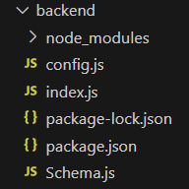

`/controllers`: Contains logic for handling requests and responses (e.g., `authController.js`).

`/models`: Mongoose schemas for the database collections.

`/routes`: Defines API endpoints for authentication (`authRoutes.js`) and complaints (`complaintRoutes.js`).

`/config`: Database connection setup (e.g., `db.js`).

**Running the Application:**

**Frontend:**

To start the frontend:

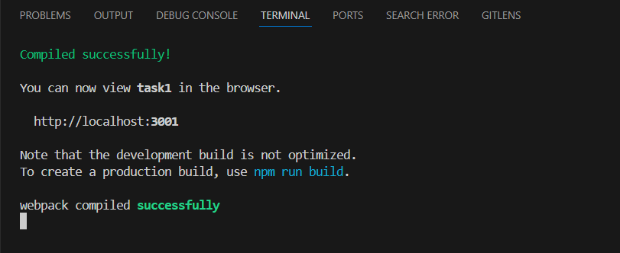

**Backend:**

To start the backend server:

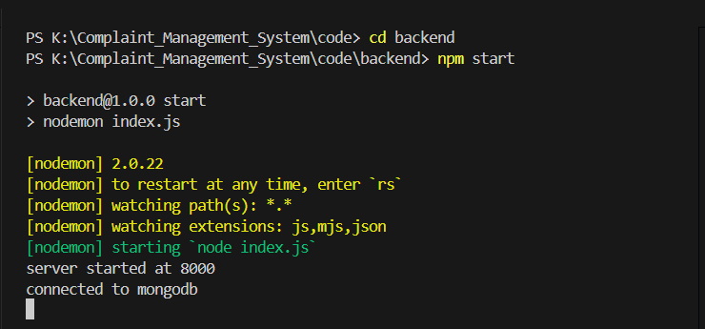

**User Interface:**

The user interface is built using Material UI, a React component library that provides modern and responsive design elements.

**Homepage:** Displays options for login or registration.

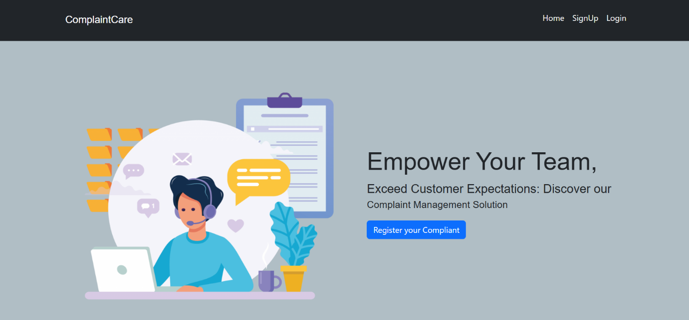

**Login/Register Page:** Forms for user authentication.

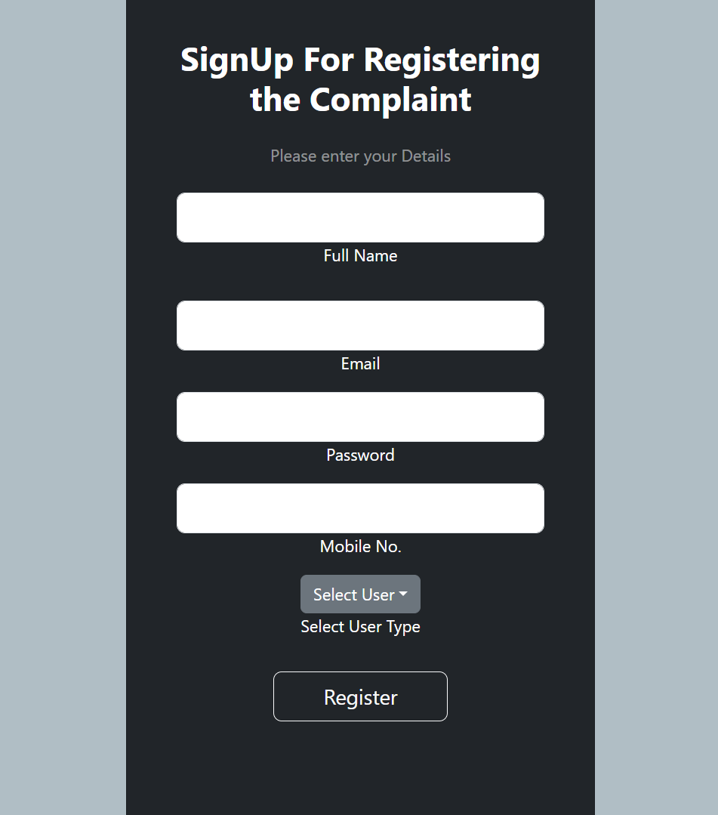

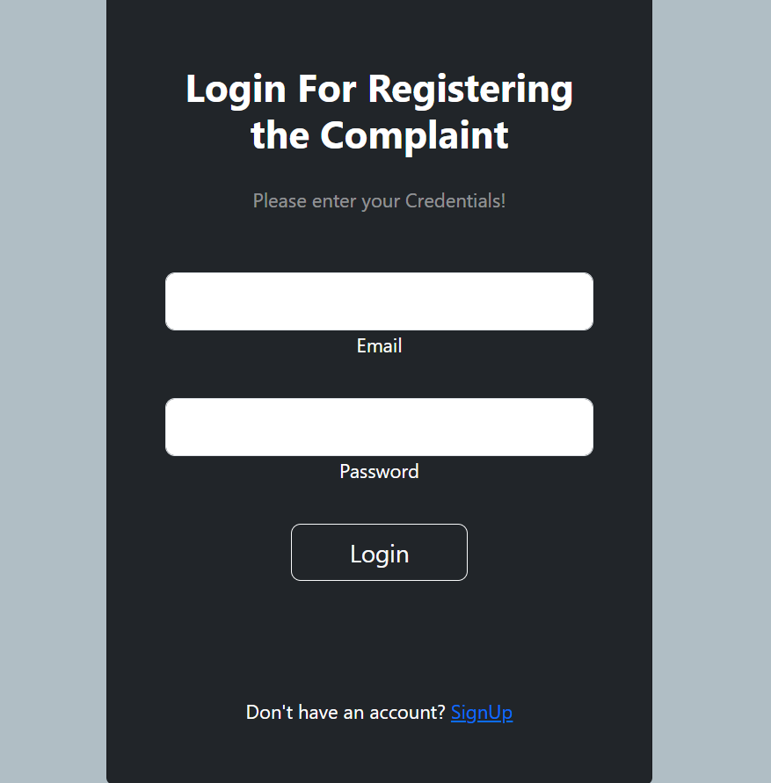

**Dashboard:** Displays the user’s submitted complaints and their status.

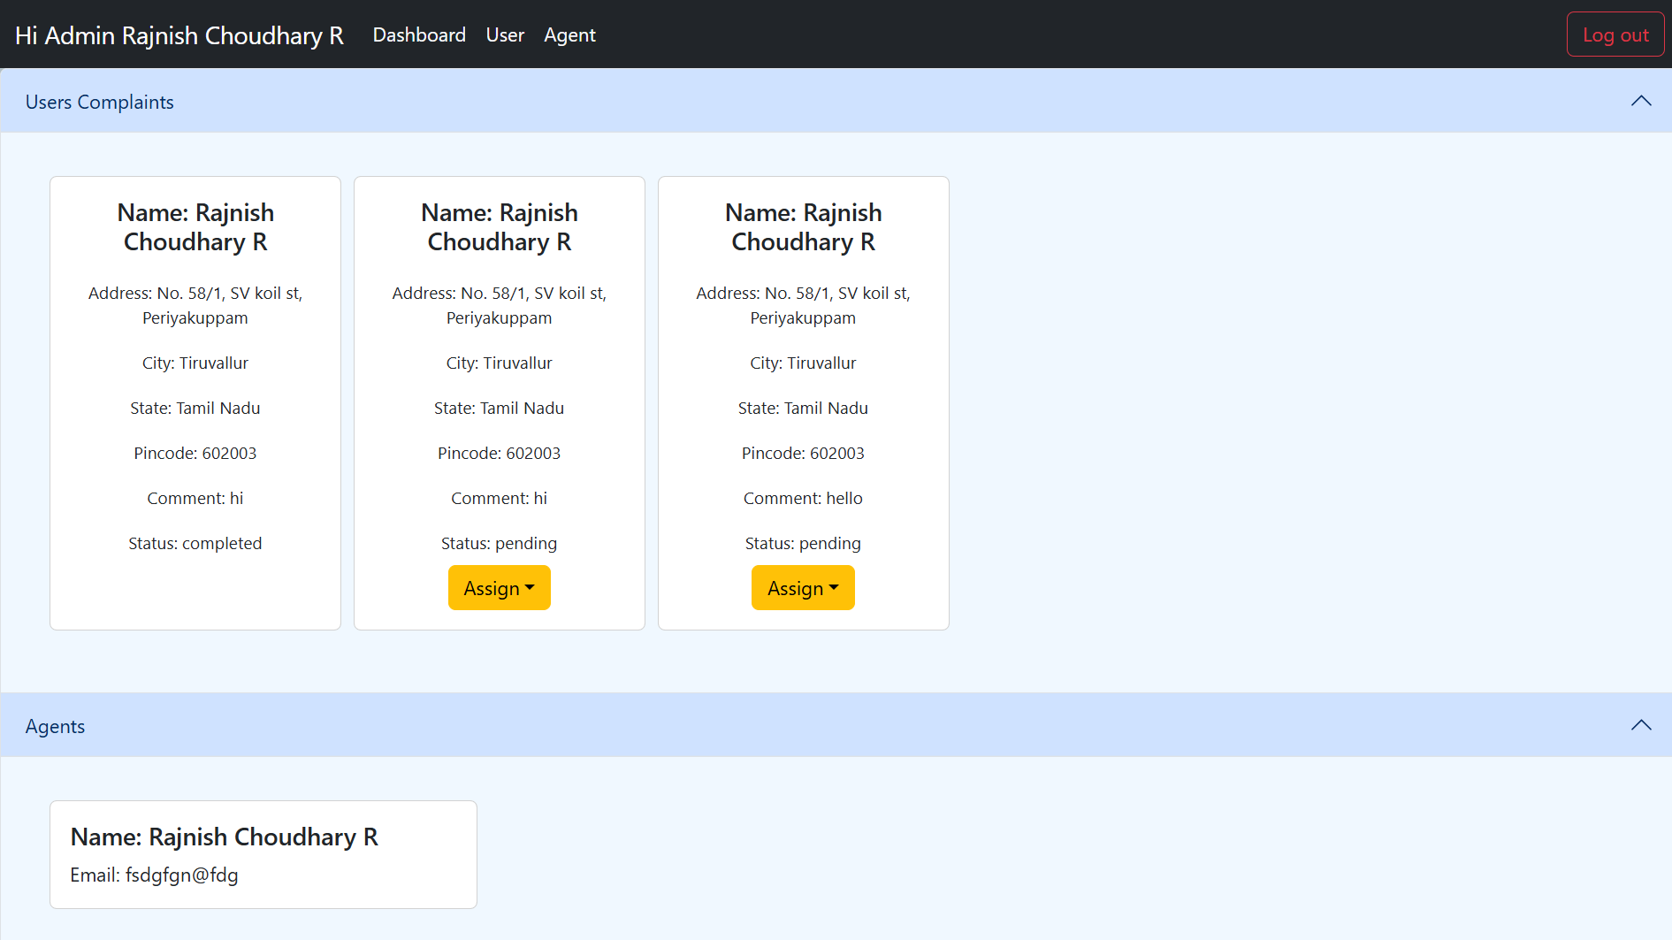

**Key Features**

The Complaint Management System (CMS) offers a range of essential features designed to improve the user experience for both the complainant and the administrators managing complaints. Below are the key features of the system:

**1. User Registration and Authentication**

- Secure User Authentication: Users and administrators are required to register and authenticate themselves using secure login credentials. Passwords are encrypted for safety, and JSON Web Tokens (JWT) are used for maintaining session integrity.

- Role-based Access: Separate roles for users and administrators allow the system to restrict access to certain functionalities, ensuring that only authorized personnel can manage complaints.

**2. Complaint Submission**

- Easy Complaint Filing: Registered users can quickly file complaints by filling out a simple form. The form captures essential details like the nature of the complaint, associated categories, and additional information to assist in resolution.

- File Attachments: Users have the ability to upload supporting documents, images, or other files to provide further context for their complaints.

**3. Real-time Complaint Tracking**

- Complaint Status Updates: Users can track the status of their complaints in real-time, including whether a complaint is "Under Review," "In Progress," or "Resolved."

- Notifications: Users are notified via email or within the system interface when there are status changes or updates to their complaints.

**4. Admin Dashboard for Complaint Management**

- Complaint Overview: Administrators have access to a centralized dashboard where they can view all submitted complaints, including details like submission date, complaint type, and current status.

- Complaint Assignment: Administrators can assign complaints to specific team members or departments based on the nature of the issue.

- Complaint Resolution: Admins can update the status of complaints, add comments, and mark complaints as resolved once action has been taken.

**5. Search and Filter Capabilities**

- Complaint Filtering: Users and administrators can filter complaints by status, category, date, or priority, enabling efficient navigation and management of complaints.

- Search Functionality: A search bar allows users and admins to quickly locate specific complaints using keywords.

**6. Analytics and Reporting**

- Analytics Dashboard: Administrators can view analytics on complaint types, resolution times, and volume of complaints to identify trends and areas for improvement.

- Exportable Reports: Admins can generate and export reports in formats like CSV or PDF, making it easier to present findings or track performance over time.

**7. Secure Data Handling**

- Data Encryption: Sensitive data such as user credentials and complaint details are encrypted to ensure that privacy is maintained.

- Role-based Authorization: The system uses role-based access control (RBAC) to restrict access to data and system functionalities based on user roles.

**8. Mobile Responsive Design**

- Accessible on All Devices: The system is designed to be responsive, ensuring that users can access the platform on various devices, including mobile phones and tablets, without any loss of functionality.

**9. Feedback Mechanism**

User Feedback: Users can provide feedback after a complaint is resolved, helping the organization evaluate satisfaction and improve the system’s effectiveness.

**10. Future Scalability**

Modular Design: The system is built with scalability in mind, allowing for the integration of additional features, such as multi-lingual support, AI-powered complaint categorization, or integration with third-party systems like chatbots or helpdesks.

**Known Issues:**

Despite its many features and functionalities, the Complaint Management System (CMS) still has some limitations that need to be addressed in future iterations. Below are the known issues currently affecting the system:

**User Role Management:**

While the system supports user authentication and role-based access control, the same dashboard is presented to both regular users and administrators. This lack of differentiation means that all users, regardless of their role, can access the same set of features. A more robust role management system would allow for separate interfaces or dashboards for users and admins, restricting certain functionalities, like complaint management or report generation, to administrators only.

**Mobile Responsiveness:**

Although the system is generally designed to be mobile-responsive, certain UI components may not display optimally on smaller screen sizes, such as mobile phones and tablets. Issues include text misalignment, buttons being cut off, and form fields not resizing correctly. Enhancing the mobile responsiveness would significantly improve the user experience for mobile users.

**Performance Under Heavy Load:**

The current version of the system has not been thoroughly tested for performance under heavy traffic conditions. As the number of users and complaints increases, the system may experience slower load times, particularly in the dashboard where complaint data is fetched from the database. Future optimization is needed to improve performance scalability.

**Limited Search and Filter Functionality:**

While basic filtering options are available for complaints, advanced search features (such as fuzzy searching or search by multiple criteria) are not yet implemented. This makes it slightly cumbersome for admins to find specific complaints, especially when dealing with a large volume of submissions.

**Error Handling and Validation:**

Error messages and form validation, while present, are fairly basic. For example, validation errors are not always descriptive enough, and the system does not currently offer real-time form validation or suggestions for correcting errors. Improving error-handling mechanisms will help users submit correct data and avoid frustration.

**Future Enhancements:**

To address the known issues and further improve the user experience, several enhancements are planned for future versions of the Complaint Management System (CMS). Below are the key future enhancements being considered:

**Admin Panel with Advanced Features:**

One of the major improvements planned is the development of a dedicated admin panel. This panel will feature advanced options such as complaint prioritization, where admins can assign urgency levels to different complaints based on their importance or category. The admin panel will also offer improved filtering capabilities, allowing admins to filter complaints by various criteria, including status, category, and submission date. Additionally, an activity log will be implemented to track actions taken by admins, such as status updates or assignments.

**Enhanced User Dashboard:**

The user dashboard will also undergo improvements, with features such as a summary of all active complaints, a timeline showing the status updates of each complaint, and a clearer navigation structure to make tracking the progress of complaints more intuitive.

**Email and SMS Notifications:**

To improve communication with users, email notifications will be added to notify them about important updates, such as when their complaint is received, reviewed, updated, or resolved. These notifications will also serve as reminders for admins when new complaints are submitted or require attention. In addition to email, SMS notifications will be considered as an alternative for users who prefer receiving updates on their mobile devices.

**Mobile Application Development:**

To enhance accessibility, a mobile application version of the CMS is planned for development, leveraging React Native to build both Android and iOS apps. This mobile app will provide the same functionality as the web platform but with a more optimized experience for mobile users. Features such as complaint submission, status tracking, and push notifications will be integrated, allowing users to manage complaints from anywhere, at any time.

**Integration with External Systems**:

Future iterations of the CMS will support integration with external services and APIs, such as customer support systems, AI-based complaint categorization tools, and third-party helpdesk software. For example, AI tools could automatically categorize complaints based on text analysis, improving the speed and accuracy of complaint management.

**Multilingual Support:**

Given the diverse user base that may use the system, multilingual support is another enhancement being considered. Users will be able to select their preferred language for both the interface and notifications, making the system more inclusive and user-friendly for non-English speakers.

**Data Analytics and Reporting Improvements:**

The analytics dashboard will be expanded to include more detailed metrics, such as average complaint resolution time, team performance, and user satisfaction ratings. Visualization tools such as graphs, charts, and heatmaps will be introduced to allow administrators to quickly assess trends in complaint data. Furthermore, custom reports can be generated based on specific parameters, such as time periods, complaint categories, or user activity.

**User Feedback Mechanism:**

Enhancing the feedback mechanism will allow users to provide more structured and detailed feedback on the resolution of their complaints. This feedback will be utilized to further improve the efficiency of the system and the quality of service provided by the organization.

**Offline Complaint Submission:**

Another planned feature is the ability to submit complaints offline via the mobile app. Users will be able to fill out complaint forms without an internet connection, and the data will be automatically uploaded to the server once the device reconnects to the internet.